**A Review of The Role of The Nucleus in Collective Cell Migration**

*Presented By:* Brady Hine

*For Partial Completion of:* MECH 498A

*Presented On:* October 6th, 2021

*Committee Members:* Dr. Ghosh, Dr. McGilvray, Dr. Puttlitz

*Word Count:* 1806

Table of Contents

Abstract 2

Introduction 2

Cellular Movement 2

Collective Migration 3

Measuring Migration 4

Current Research 5

Gaps in Current Research 8

References 10

# Abstract

Cell migration is a fundamental physiological process in normal physiology and pathology. The cell nucleus is emerging as a key player in this process [1], [2]. Being the largest and stiffest organelle, in the eukaryotic cells, the nucleus acts as a limiting factor during cell migration. The role of nuclear mechanics in the cell migration is therefore a topic of recent interest to both the basic science and clinical research communities.

This research proposes to study how nuclear mechanical properties affect collective cell migration using a model system of the scratch wound assay. Through live time lapse imaging, cell migration parameters will be quantified. High resolution live imaging of the nucleus and cytoskeleton will be performed which will allow us to develop strain maps at the cell monolayer, thus providing detailed mechanical insight of the process. Further studies might be performed to understand the synergistic role of nuclear mechanics with cell crowding effects and differing substrate mechanics.

# Introduction

In order to quantitatively assess the role of the nucleus in collective cell migration, it is important to understand the trajectory of single cells in the context of collective cell migration, and to decide on some parameters to quantify the trajectory of migration.

## Cellular Movement

Cell movement is a crucial event for organisms during complex processes of development as well as for a number of physiological and pathological functions such as wound healing or cancer metastasis [1]. While multiple types of cell motility exist, this review will focus primarily on cell crawling. In this motility mode, cells generally move in response to external chemical or physical signals in the environment detected by focal adhesions connected to the cytoskeleton [3]. As this movement occurs, the primary forces experienced by the cell come from external factors, such as viscous forces of the surroundings, and internal forces created by the cytoskeleton. Although the cytoskeleton is composed of actin filaments, microtubules, and intermediate filaments, it is the actin cytoskeleton that is generally referred to as the engine of motility. This is due to the actin network driving the first step of cell movement through protrusion. The asymmetric polymerization that actin filaments undergo in the presence of polarized concentrations of actin monomers generates the forces needed for this process. After protrusion of the leading edge, the cell membrane adheres to the substrate on the leading edge and retracts the adhesion from the tailing edge. Finally, the cell body is then pulled forward by forces generated by myosin motor proteins sliding on the actin network [4]. This dependence on actin for motion causes many cell types to polarize their microtubule organizing centers and Golgi apparatus in the direction of movement [5].

## Collective Migration

Movement of a single cell is an intricate process that increases in complexity in the context of collective migration. When a group, sheet, or chain of cells move together, there are additional forces due to cell-cell adhesion effects via adherens-junction proteins coupled to the cytoskeleton [6]. These junctions connect cells to their neighbors and allow for both chemical and mechanical communication providing the cells the ability to influence one another. This gives rise to a system in which leader cells detect external signals and influence follower cells which influence each other [3]. It’s recently been shown that leader cells tend to cluster toward the front of cell groups and it is the pulling forces of these cells that drives migration [7]. These cell-cell interactions and communication are attributed to why collective migration of cells is observed to be faster and more efficient than if the cells were to migrate individually [8].

## Measuring Migration

The scratch wound assay is a simple technique to quantify some standard collective cell migration parameters such as speed, persistence, and polarity. While cell speed can be thought of simply by the distance traveled over time, persistence is defined as a ratio of start to end point distance compared to the total path length. Speed and persistence calculations can be seen in equations 1 and 2 respectively where V is velocity, P is persistence, t is time, s is traversed path length, and d is the start to end point distance over time [9].

$V = \frac{s}{t-t_{0}}$ Eq. 1

$P = \frac{d}{s}$ Eq. 2

In the scratch wound assay, a sheet of cells is scratched with a pipette tip causing the cells to move perpendicular to the wound to seal it. This begins the migration process from a defined starting point and allows the use of time-lapse imaging and image processing to capture speed and directional persistence data. Various markers can also be used to quantify polarization of the Golgi apparatus, cytoskeleton strain, or nuclear movements over the cell monolayer [5]. Another parameter of significance in this assay is the average cell migration rate determined by observing how the wound area is changing over time. This can be calculated using equation 3 where RM is the rate of cell migration in nm/h, t is time in hours, and Wi and Wf are the average initial and final wound widths respectively in nm [10].

$R_{M}= \frac{W_{i}-W_{f}}{t}$ Eq. 3

Related to the cell migration rate, another parameter of interest is the percentage of wound closure observed at any given time during the scratch wound assay. This percentage can be determined using equation 4 below where WC represents wound closure, A0 is the wound area measured after scratching, and At is the measured wound area at a given time t [10].

$W_{C}= \frac{A_{0}-A_{t}}{A_{t}}*100\%$ Eq. 4

# Current Research

The physical role of the nucleus in cellular migration has been a less understood one. This began to change with recent studies uncovering the mechanical links between the nucleus and cytoskeleton. These discoveries established a pathway for forces to be transmitted between the nucleus and cytoskeleton. It is now known that the nuclear envelope is composed of two concentric membranes that possesses many transmembrane proteins, which includes the linker of nucleoskeleton and cytoskeleton (LINC) complexes involving nesprin and the SUN protein domain [11]. SUN proteins exist on the inner nuclear membrane and connect directly to nesprin proteins on the outer nuclear membrane which associate with the cytoskeleton. SUN proteins also associate with intermediate filaments, known as lamin A, lamin B, and lamin C, inside the nuclear membrane which constitutes the nucleoskeleton as seen in figure 1 [12].

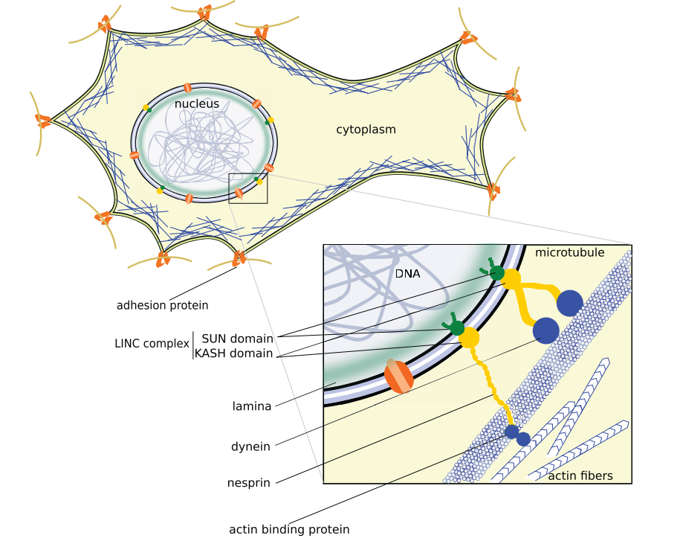

Figure 1: A labelled visual representation of the LINC complex connecting the nucleoskeleton and cytoskeleton creating a mechanical stress transmission pathway [12]

It is thought that lamin A and lamin C generate nuclear rigidity as cells with low levels of these have observed more deformable nuclei. This is in contrast to lamin B which appears to have only a minute effect on nuclear deformability. This allows the nucleus to be mechanically active by either upregulating or downregulating lamin A/C to increase or decrease stiffness respectfully in accordance to the external environment [12]. The influence of the external environment’s effect on migration was highlighted in a study by Ng et al., which observed the effects of substrate stiffness on cell migration using a scratch wound assay. Their findings showed significant differences in cell speed, persistence, directionality, and coordination between soft and stiff substrates showing that collective migration is a mechanosensitive process. They also observed that there were different responses to treatment between single-cell and collective migration suggesting “distinct mechanisms for mechanosensing [9].”

In an experiment done by Graham et al., the team was looking to more rigorously define the nucleus’ role using enucleated mammalian cells (cytoplasts) [2]. The group’s findings showed that directed cell migration and polarity establishment could still occur without a nucleus for one- and two-dimensional migration but not for three-dimensional. While one- and two-dimensional migration was still able to occur, cytoplast migration speeds were lower than intact cells and decreased by 0.12 µm/h over 24 h. A scratch wound assay also displayed this decreased efficiency with intact cells closing the wound in a mean of 5.4 h and cytoplasts only closing 95.6% of the wound over 16 h. The results were likely associated with cytoplasts being able to exert less force without a nucleus and highlighted that the nucleus is “critical for proper cell mechanical responses [2].”

It has been a popular hypothesis that nuclear mechanical properties are a limiting factor for migration especially in 3D matrices. As the nucleus is the largest and stiffest organelle in a cell and must deform when passing through constrictions, Heo et al. looked to modifying nuclear stiffness as a possible solution [13]. This was done by using lentiviral-mediated knockdown to inhibit lamin A/C and trichostatin A (TSA) to decrease heterochromatin content softening the nucleus of meniscal cells and seeing the effect on the ability of these cells to migrate through dense fibrous networks. It was observed that cells treated with TSA had more deformable nuclei and showed enhanced migration in both planar migration through pores and invasion into fibrous networks. Verification of nuclear softening being the primary cause of enhanced migration was done by observing similar results in cells with lamin A/C knockdown [13]. These results are consistent with other experiments observing migration efficiencies and nuclear mechanical properties. One of which involved observing varying levels of metastatic prostate cancer cells, their nuclear stiffnesses, and migration abilities [14]. These lower nuclear stiffnesses are believed to be associated with chromatin structure and compactness. It has been shown that cells treated with chromatin decondensing drugs yield softer and more deformable nuclei [15]. This decondensed chromatin structure is also seen naturally in stem cells that have a high transcription activity level and thus is also present in metastatic cancer cells as many of these cells have high transcription activity. This experiment involved the use of a nuclear creep experiment in a microfluidic channel and observed the time for varying levels of metastatic prostate cancer cells to pass through a tight constriction. The images taken were then also used to determine the nuclear stiffness of these cell types. The team’s results showed that there was a correlation of more aggressive cancer cells having lower nuclear stiffnesses and higher migration ability [14].

# Gaps in Current Research

The goal of this research is to expand upon previous work on how nuclear mechanical properties affect cell migration and observe how these effects pertain to a large cell collective. While parameters of these effects have been measured to some degree, many previous experiments have relied on a small number of cells. By studying collective migration of cells with modified nuclear stiffness and chromatin remodeling, large scale quantifications can be made using live time lapse imaging. High resolution live imaging of the nucleus and cytoskeleton will be performed allowing us to develop strain maps at the cell monolayer providing detailed mechanical insight of this process. Further studies might then be performed to understand the synergistic role of nuclear mechanics with cell crowding effects and differing substrate mechanics.

# References

[1] S. Jain *et al.*, “The role of single-cell mechanical behaviour and polarity in driving collective cell migration,” *Nat. Phys. 2020 167*, vol. 16, no. 7, pp. 802–809, May 2020, doi: 10.1038/s41567-020-0875-z.

[2] D. M. Graham *et al.*, “Enucleated cells reveal differential roles of the nucleus in cell migration, polarity, and mechanotransduction,” *J. Cell Biol.*, vol. 217, no. 3, pp. 895–914, Mar. 2018, doi: 10.1083/JCB.201706097.

[3] C. De Pascalis and S. Etienne-Manneville, “Single and collective cell migration: the mechanics of adhesions,” *https://doi.org/10.1091/mbc.e17-03-0134*, vol. 28, no. 14, pp. 1833–1846, Oct. 2017, doi: 10.1091/MBC.E17-03-0134.

[4] R. Ananthakrishnan and A. Ehrlicher, “The Forces Behind Cell Movement,” *Int. J. Biol. Sci.*, vol. 3, no. 5, p. 303, Jun. 2007, doi: 10.7150/IJBS.3.303.

[5] G. Cory, “Scratch-Wound Assay,” *Methods Mol. Biol.*, vol. 769, pp. 25–30, 2011, doi: 10.1007/978-1-61779-207-6_2.

[6] F. Thüroff, A. Goychuk, M. Reiter, and E. Frey, “Bridging the gap between single-cell migration and collective dynamics,” *Elife*, vol. 8, Dec. 2019, doi: 10.7554/ELIFE.46842.

[7] O. du Roure *et al.*, “Force mapping in epithelial cell migration,” *Proc. Natl. Acad. Sci.*, vol. 102, no. 7, pp. 2390–2395, Feb. 2005, doi: 10.1073/PNAS.0408482102.

[8] R. Mayor and S. Etienne-Manneville, “The front and rear of collective cell migration,” *Nat. Rev. Mol. Cell Biol. 2016 172*, vol. 17, no. 2, pp. 97–109, Jan. 2016, doi: 10.1038/nrm.2015.14.

[9] M. R. Ng, A. Besser, G. Danuser, and J. S. Brugge, “Substrate stiffness regulates cadherin-dependent collective migration through myosin-II contractility,” *J. Cell Biol.*, vol. 199, no. 3, p. 545, Oct. 2012, doi: 10.1083/JCB.201207148.

[10] A. Grada, M. Otero-Vinas, F. Prieto-Castrillo, Z. Obagi, and V. Falanga, “Research Techniques Made Simple: Analysis of Collective Cell Migration Using the Wound Healing Assay,” *J. Invest. Dermatol.*, vol. 137, no. 2, pp. e11–e16, Feb. 2017, doi: 10.1016/J.JID.2016.11.020.

[11] T. Bouzid *et al.*, “The LINC complex, mechanotransduction, and mesenchymal stem cell function and fate,” *J. Biol. Eng. 2019 131*, vol. 13, no. 1, pp. 1–12, Aug. 2019, doi: 10.1186/S13036-019-0197-9.

[12] A. Fruleux and R. J. Hawkins, “Physical role for the nucleus in cell migration,” *J. Phys. Condens. Matter*, vol. 28, no. 36, p. 363002, Jul. 2016, doi: 10.1088/0953-8984/28/36/363002.

[13] S. J. Heo *et al.*, “Nuclear softening expedites interstitial cell migration in fibrous networks and dense connective tissues,” *Sci. Adv.*, vol. 6, no. 25, pp. 5083–5102, Jun. 2020, doi: 10.1126/SCIADV.AAX5083.

[14] Z. S. Khan, J. M. Santos, and F. Hussain, “Aggressive prostate cancer cell nuclei have reduced stiffness,” *Biomicrofluidics*, vol. 12, no. 1, p. 014102, Jan. 2018, doi: 10.1063/1.5019728.

[15] K. M, T. R. J, and W. K, “Probing the compressibility of tumor cell nuclei by combined atomic force-confocal microscopy,” *Phys. Biol.*, vol. 10, no. 6, Dec. 2013, doi: 10.1088/1478-3975/10/6/065002.